**DAILY ONLINE ACTIVITIES SUMMARY**

|  |  |  |  |  |  |  |
| --- | --- | --- | --- | --- | --- | --- |
| **Date:** | **29/05/2020** | | | **Name:** | **Shashikant Chavan** | |
| **Sem & Sec** | **8th- B** | | | **USN:** | **4AL16CS090** | |
| **Certification Course Summary** | | | | | | |
| **Course** | **Python Programming In Hindi** | | | | | |
| **platform** | | **GreatLeeraning** | **Duration** | | | **3 hours** |
| **Coding Challenges** | | | | | | |
| **Problem Statement:**  **1)** **Print the floor of the expected value(mean) of the subarray from L to R.**  Input:  **.** | | | | | | |
| **Status: Executed** | | | | | | |
| **Uploaded the report in Github** | | | **Yes** | | | |
| **If yes Repository name** | | | <https://github.com/alvas-education-foundation/Shashikant> _chavan | | | |
| **Uploaded the report in slack** | | | **Yes** | | | |

Online test

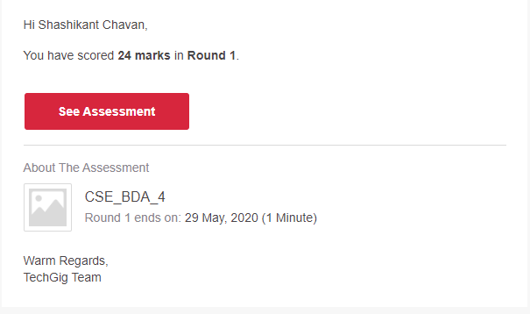

Certification:



Coding Challenges Details:

